Compute Options

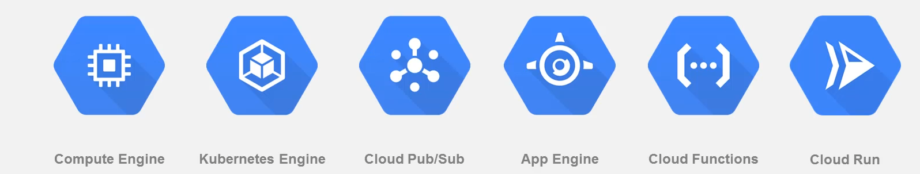

Compute Engine:

* It provides scalable VM of all sizes from micro to 160 CPU and 3.75TB storage
* Provides global load balancing to distribute traffic across pool of instances
* Local SSD of 3 TB and network storage of 64 TB in size -encypted
* The infra is maintained seemelessly with live-migration.

Kubernetes Engine:

* Fully managed container orchestration tool using Kubernetes
* Autoscaling on a high scaling global network
* VPC provides secure, isolated container networks
* Fully managed node experience, node auto repair, node upgrade, node pool.

Cloud Pub-Sub:

* It’s a enterprise message system which can handle millions of messages per second
* It is used to ingest data from sensors, data streaming, asyn workflows and logging to multiple systems.
* It is used for handling events and works with compute/App Engine/Storage/Cloud Function.
* It’s used by companies like Spotify to process millions of request per second.

App Engine:

* Fully managed serverless application platform
* Supports many languages like Java, C++, python , go
* Auto-scaling of application, infrastructure and network optimisation.
* Used by Ed-tech companies like Khan Academy and mobile companies like Rovio

Cloud Function:

* Easiest way to run the code in cloud serverless i.e no server provision
* Extends to most products and services in Google Cloud Platform.
* Real-time data processing and ability to integrate third party policies.
* Used for virtual-assistant , chatbots and video/image sentiment analysis.

Cloud Run:

* Serveless execution of containerized app over Http
* Concurrent http or pub/sub request to running containers
* Run in kubernetes or standalone